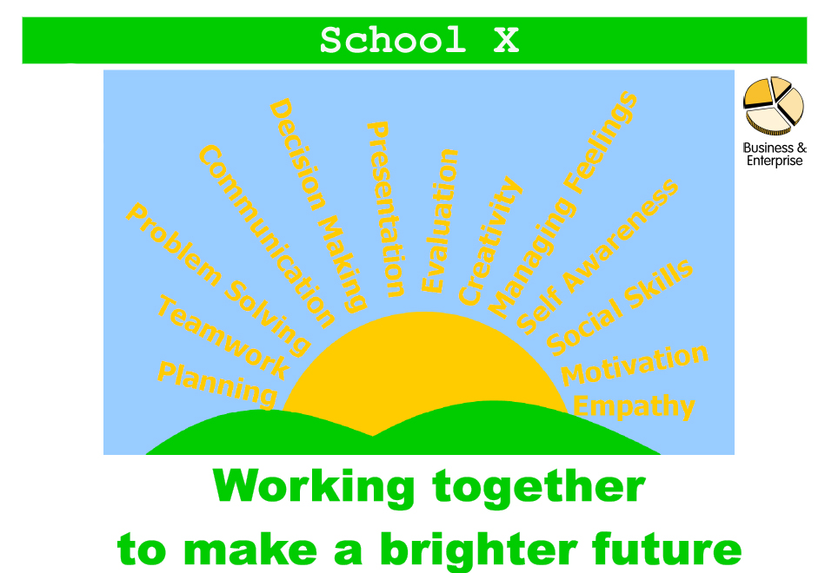
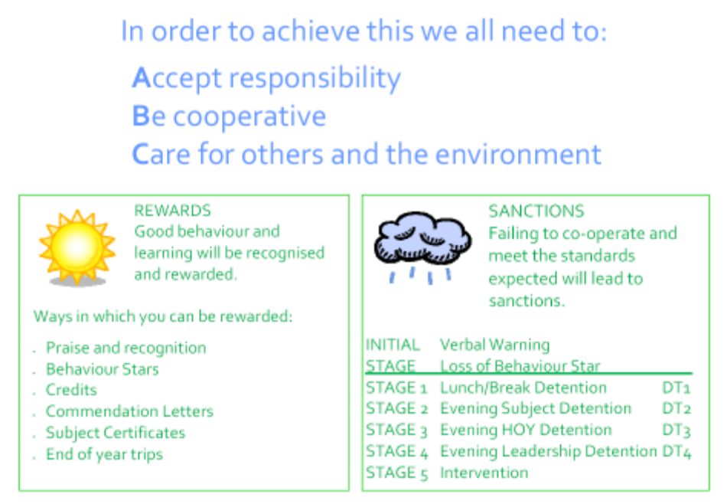
The poster opposite is displayed in all classrooms and sets out our vision for the enterprising ethos of the school.
The sunrise image shows the ‘Enterprise Skills’ which were identified in our application for specialism and have been
used since as the basis for enterprise activities. We believe the ‘Enterprise Skills’ to be transferrable skills that, if well
developed and utilised, lead to successful and enterprising futures.
The ‘Enterprise Skills’ are the first eight skills shown on the sunrise:
PLANNING
TEAMWORK
PROBLEM SOLVING
COMMUNICATION
DECISION MAKING
PRESENTATION
EVALUATION
CREATIVITY (this has been added to the original skills)
The following five words are the SEAL (SOCIAL and EMOTIONAL ASPECTS of LEARNING) attributes. These are:
MANAGING FEELINGS
SELF AWARENESS
SOCIAL SKILLS
MOTIVATION
EMPATHY
These attributes follow on from the ‘Enterprise Skills’ as important aspects which make up the whole person and
contribute to the success of an individual.
The statement below the sunrise…
Working together to make a brighter future
…is the driving statement for our ‘Enterprising Ethos’. It refers to every individual at School X, highlighting the need
for teaching staff, support staff, students and parents to work together to make a brighter future for all.
The ABC statements are important in dialogue with students and set out, briefly and simply, our expectations for staff
and students in order to maintain the ‘Enterprising Ethos’.
Accept responsibility
Be cooperative
Care for others and the environment
Staff are expected to use these statements in dialogue with students. Students will be aware through assemblies and the
posters will be clear for all to see on classroom walls. If followed they lead to rewards, and if not there are sanctions.
These are briefly displayed at the bottom of the poster.

